

A LOW-CODE FRAMEWORK FOR CONVERSATIONAL AI ASSISTANTS LEVERAGING RETRIEVAL-AUGMENTED GENERATION AND LLMs

PROJECT DISSERTATION II REPORT
Submitted by
THANIGAIVELG
Reg.No : 24880107
in partial fulfilment of the award of the degree of
MASTER OF ENGINEERING
IN
COMPUTER SCIENCE AND ENGINEERING DEPARTMENT OF COMPUTER SCIENCE AND ENGINEERING
SCHOOL OF ENGINEERING
VELS INSTITUTE OF SCIENCE, TECHNOLOGY & ADVANCED STUDIES(VISTAS)
PALLAVARAM, CHENNAI 600117

MAY 2026

BONAFIDE CERTIFICATE

Certified that this project “A LOW-CODE FRAMEWORK FOR CONVERSATIONAL AI ASSISTANTS LEVERAGING RETRIEVAL-AUGMENTED GENERATION AND LLMs” is the bonafide work of THANIGAIVEL G (24880107) who carried out the project under my supervision. Certified further, that to the best of my knowledge the work reported here does not form part of any other project report or dissertation on the basis of which a degree or award was conferred on an earlier occasion on this or any other candidate.

SIGNATURE SIGNATURE
Dr.S. SRIDEVI, M.E, Ph.D, Dr.S. THIRUMAL M.E, Ph.D
Associate Professor, Associate Professor,
Head of the Department, Supervisor,
Department of CSE, Department of CSE,
VISTAS, VISTAS,
Chennai – 600 117. Chennai – 600 117.

Submitted for the project work and viva - voice examination held on
…………… at Vels Institute of Science, Technology and Advanced Studies (VISTAS), Chennai – 600 117.

INTERNAL EXAMINER EXTERNAL EXAMINER

ACKNOWLEDGEMENT

It is certainly a great delight and proud privilege to acknowledge the help and support I received from the positive minds around me in making this venture a successful one. The infrastructural support with all kinds of lab facilities have been a motivating factor in this completion of project work, all because of FOUNDER & CHAIRMAN, Shri. Dr. ISHARI K. GANESH.,
with great pleasure that I take this opportunity to thank him. I am grateful to our DIRECTOR, DR.K. KALAIVANI M.E. Ph.D., & HEAD OF THE DEPARTMENT, Dr.S. SRIDEVI, M.E. Ph.D., for her continuous support for the project, from initial advice and contacts in the early stages of conceptual inception, and through on-going advice and encouragement to this day.

I extend our warmest thanks to my INTERNAL GUIDE, Dr. N KUMAR M.Tech. Ph.D., Dr. S. THIRUMAL M.E. Ph.D., who has patiently guided and provided us with invaluable advice and help. I am thankful to my Project Coordinator Dr. S. THIRUMAL M.E. Ph.D., I would like to express my greatest gratitude to our staff members, librarian and non-teaching staff members of Computer Centre, who have helped and supported me throughout. Last but not the Least, I wish to thank my PARENTS and my friends for their individual support and interest who has inspired me and encouraged me to go in my own way, without them I would be unable to complete this project.

THANIGAIVEL G - 24880107

ABSTRACT

Conversational AI assistants have evolved rapidly with the rise of large language models (LLMs). However, developing customized assistants that integrate external knowledge, handle domain-specific queries, and maintain cost-efficiency still demands advanced programming skills. To address this, the proposed work introduces a low-code framework for building and deploying conversational AI assistants that leverage Retrieval-Augmented Generation (RAG) and LLMs.
The framework enables non-expert users to design intelligent dialogue systems through a drag-and-drop interface. Developers can connect components such as data ingestion, vector indexing, retriever, and LLM modules without extensive coding. A pipeline based on semantic retrieval augments the LLM context with relevant documents, enabling accurate and verifiable responses.
The proposed system combines a Low-Code Designer (for UI and workflow creation), a RAG Engine (for contextual retrieval), and an LLM Runtime (for natural-language reasoning and response generation). Tools such as LangChain, FAISS/Pinecone, FastAPI, and OpenAI/Hugging Face models are employed. Performance is evaluated using accuracy, latency, and usability metrics. The framework aims to democratize the development of advanced conversational agents.

TABLE OF CONTENTS

CHAPTER NO. TITLE PAGE NO. ABSTRACT iii

ACKNOWLEDGEMENT iv

LIST OF FIGURES ix

LIST OF ABBREVIATIONS x

1 | INTRODUCTION | 9
 | 1.1 OVERVIEW | 9
 | 1.2 OBJECTIVE | 9
 | 1.3 SCOPE OF THIS PROJECT | 10
 | 1.4 PROBLEMT STATEMENT | 10
 | 1.5 EXISTING WORK | 11
 | 1.6 PROPOSED WORK | 12
 | 1.6.1 Objective | 12
 | 1.6.2 System Architecture | 12
 | 1.7 SYSTEM SPECIFICATION | 13
 | 1.7.1 Hardware Requirements | 13
 | 1.7.2 Software Requirements | 13

1.7.3 Tools and Technologies Used 14

1.8 IMPLEMENTATION 14
    - Module Description 14
    - Algorithmic Flow 15
1.8.3 Key Screens / Outputs 16
- LITERATURE SURVEY 17
  - INTRODUCTION 17
  - LITERATURE SURVEY 17
- SYSTEM DESIGN AND UI ARCHITECTURE 21
  - OVERVIEW 21
  - SYSTEM DESIGN APROACH 21
  - UI MODULES DESIGNED 22
  - DESIGN METHODOLOGY 23
  - EVALUATION OF UI DESIGN 23
  - SUMMARY 24

- IMPLEMENTATION AND RESULTS
  - OVERVIEW 25
  - TOOLS AND TECHNOLOGIES USED 25
  - IMPLEMENTATION DETAILS 26
    - Login Page 26
    - Dashboard 26
    - Data Upload Screen 26
    - Workflow Builder 26
    - Chat Interface 27
    - Admin Panel 27
  - TESTING AND VALIDATION 27
  - SUMMARY 28
- CONCLUSIONS & FUTURE WORK 29
  - CONCLUSION 29
  - FUTRE WORK AND EXTENSION 29
REFERENCES 31
CONFERENCE CERTIFICATE 32

FIGURE NO. | LIST OF FIGURES  DESCRIPTION | PAGE NO.
1.1 | System Architecture | 13
1.2 | Process Flow Diagram | 15
1.3 | End User Chat Interface | 16
1.4 | RAG Source Upload Screen | 17
1.5 | Admin Panel | 17
3.1 | Oracle APEX Design Page | 24
4.1 | Low Code Framework | 28

LIST OF ABBREVIATIONS

AI Artificial Intelligence

LLM Large Language Model

RAG Retrieval-Augmented Generation

UI User Interface

API Application Programming Interface

JSON JavaScript Object Notation

NLP Natural Language Processing

FAISS Facebook AI Similarity Search

GUI Graphical User Interface

CHAPTER 1 INTRODUCTION
  - OVERVIEW

Conversational AI has transformed the way humans interact with digital systems. Traditional chatbots depend on manually written intents and rule-based flows, limiting their scalability and adaptability. The emergence of LLMs such as GPT-4, Claude, and Gemini has enabled more natural and context-aware interactions. Nevertheless, incorporating domain-specific knowledge into these models remains challenging due to token-limit constraints and the high cost of retraining.
Retrieval-Augmented Generation (RAG) addresses this limitation by combining a retrieval component with the generative capabilities of an LLM. When a query is issued, the retriever searches an indexed knowledge base, and the retrieved passages are provided as context to the LLM for response generation.
Despite this advancement, the integration of RAG and LLMs still demands significant coding expertise. Hence, the objective of this research is to build a low-code framework that simplifies the process of constructing conversational AI assistants capable of leveraging RAG and LLMs efficiently.

OBJECTIVES
The primary objective of this project is to develop and integrate a Large Language Model (LLM) based smart assistant that simplifies user interaction with enterprise applications through a conversational interface. The assistant leverages Retrieval-Augmented Generation (RAG) to understand user queries and retrieve relevant documents, reports, and data from enterprise systems. By utilizing low-code tools and reusable components, the project aims to minimize development effort and reduce technical complexity during implementation.
The system is designed to improve accessibility of enterprise data and reports, allowing users to obtain insights and perform actions through natural language queries. Furthermore, the project focuses on building an extensible architecture that can seamlessly support future enterprise modules such as ERP and CRM. Emphasis is also placed on ensuring a secure, scalable, and compliant framework suitable for enterprise environments, enabling efficient integration and reliable performance across various business functions.

SCOPE OF THIS PROJECT

The scope of this project encompasses the development of a low-code framework for building intelligent conversational assistants that integrate Large Language Models (LLMs) with enterprise data through Retrieval-Augmented Generation (RAG). The system enables non-technical users to visually design and deploy AI-powered chatbots, reducing dependency on software developers and minimizing manual coding efforts. Its modular architecture allows for easy customization, extension, and reuse of components such as data connectors, vector stores, and LLM blocks.

The framework can be applied across diverse enterprise domains, including ERP, CRM, HR, and customer support, providing unified and context-aware access to organizational knowledge. It supports scalability, integration with cloud environments and APIs, and secure data handling with role-based access control.

PROBLEM STATEMENT
Existing chatbot platforms present significant limitations in terms of flexibility and accessibility. Most available solutions either demand substantial programming expertise or rely on predefined intents, which restricts their intelligence and adaptability. As a result, domain experts who lack technical or coding backgrounds face challenges in building conversational assistants capable of reasoning over custom enterprise knowledge.
Moreover, the absence of robust low-code frameworks that effectively integrate Large Language Models (LLMs) with Retrieval-Augmented Generation (RAG) further limits the accessibility, reusability, and scalability of such systems. This gap highlights the need for a user-friendly, intelligent, and low-code solution that empowers non-technical users to create and manage advanced enterprise assistants efficiently.

EXISTING WORK
Traditional conversational AI systems typically adopt either rule-based or intent-based NLP models, such as Dialogflow or Rasa, which depend heavily on predefined utterances and extensive training data. While effective for structured interactions, these models lack flexibility and require frequent updates to handle new scenarios. On the other hand, purely LLM-based architectures can generate fluent and coherent responses but often suffer from factual inaccuracies or hallucinations when sufficient context is not provided. Both approaches present key challenges, including high developer dependency, expensive retraining efforts to incorporate new data, and limited control over contextual grounding.
Recent advancements, such as Retrieval-Augmented Generation (RAG), attempt to address these issues by combining retrieval mechanisms with generative models to enhance factual accuracy and contextual relevance. However, current frameworks like LangChain and LlamaIndex still demand scripting and programming expertise, creating a barrier for non-technical users. There remains a clear gap for a unified low-code platform that enables domain experts to visually design, configure, and deploy complete RAG-LLM pipelines without deep technical intervention.

PROPOSED WORK

Objective:
The proposed Low-Code Conversational AI Framework introduces a visual, drag-and-drop interface that abstracts the underlying complexity of building and managing LLM-based pipelines. This framework empowers users to create intelligent assistants without requiring deep programming knowledge by assembling prebuilt functional blocks. The system includes a Data Connector module for document upload and preprocessing, an Embedding Generator that converts text into vector representations using models such as OpenAI’s text-embedding-3 or Sentence-Transformers, and a Vector Store powered by FAISS or Pinecone for efficient similarity search.
A Retriever component enables semantic search to fetch contextually relevant data, while the LLM Block utilizes the retrieved context to generate accurate, context-aware responses. Finally, the Interface Block allows seamless integration through a web-based user interface or API endpoint. Together, these components form an intuitive, modular architecture that simplifies the development and deployment of RAG-powered conversational assistants within enterprise environments.

System Architecture:
- User Interface Layer – A drag-and-drop GUI built using Streamlit or Node-RED allows visual composition of pipelines.
- Processing Layer – Converts visual workflows into executable Python code.
- RAG Engine – Handles chunking, embedding, storage, and retrieval of documents.
- LLM Runtime – Manages prompt templates, response parsing, and API calls.
- Monitoring & Analytics Layer – Tracks token usage, latency, and feedback.
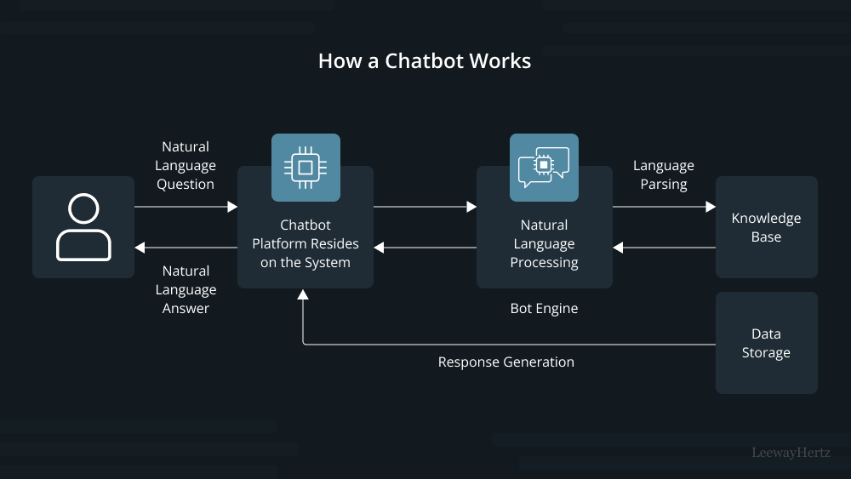

Figure 1.1: System Architecture

SYSTEM SPECIFICATION

Hardware Requirements
- Processor: Intel i5 / Ryzen 5 or higher
- RAM: 16 GB (minimum 8 GB)
- Storage: SSD 256 GB or higher
- GPU (optional): NVIDIA T4/RTX for local model execution

Software Requirements
- OS: Windows 10 / Ubuntu 22.04
- Language: Python 3.11
- Frameworks: LangChain, FastAPI, Streamlit, Pandas, NumPy
- Database/Vector Store: FAISS / ChromaDB / Oracle 26ai
- LLM APIs: OpenAI GPT-4 / Llama 2 / Cohere
- IDE: VS Code / Jupyter Notebook

Tools and Technologies Used
- Low code Platform - Oracle APEX – For building UI, managing session state, and calling REST services.
- LLM & AI Framework - OpenAI GPT-4 / Cohere / Hugging Face Transformers LangChain / LlamaIndex – For orchestrating the RAG
- Storage & Retrieval - ChromaDB / FAISS / Oracle 26ai – Vector search for document embeddings and Oracle DB – Core ERP database.
- Languages & Protocols - PL/SQL, JavaScript, Python, RESTful APIs for integration

IMPLEMENTATION

Module Description
- Data Ingestion Module
  - Uploads documents (PDF, CSV, TXT).
  - Performs chunking and text cleaning.
- Embedding Module
  - Converts text chunks → dense vectors using Cohere or OpenAI embedding models.
- Vector Storage and Retrieval
  - Stores embeddings in FAISS index / Oracle 26ai Database has the support to store the vectors within the database table.
  - Performs cosine similarity search for relevant documents.
- Prompt Construction Module
  - Dynamically injects retrieved context into prompt templates.
- LLM Response Generation
  - Invokes GPT-4 / Llama 2 / Cohere API to generate answers.
  - Post-processes output for citations and formatting.

- Low-Code Interface
  - Built using Oracle APEX – Low code platform, which provides the drag and drop design. Developed the screens for Upload Data, Generate Embeddings, Response Retrieval.
- Deployment Module
  - Deployed and hosted on the free cloud workspace provided by Oracle and the chat interface can be integrated into web or enterprise applications.

Algorithmic Flow
- User uploads knowledge documents.
- Text is split into manageable chunks.
- Embeddings are generated and stored in vector database.
- User query - retriever fetches top-k relevant chunks.
- Prompt is constructed with retrieved context + query.
- LLM generates contextual response.
- Response is returned to the chat UI and logged for evaluation.
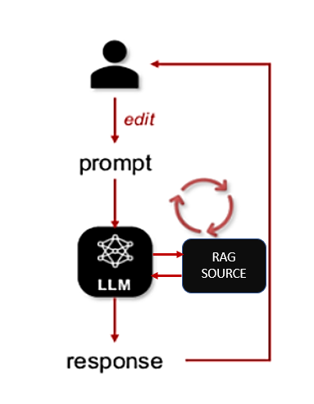

Figure 1.2 Process Flow Diagram

Key Screens / Outputs
- Workflow Builder UI – drag-and-drop canvas for RAG components.
- Chat Interface – test conversations and inspect retrieved sources.
- Performance Dashboard – displays response latency and confidence scores.
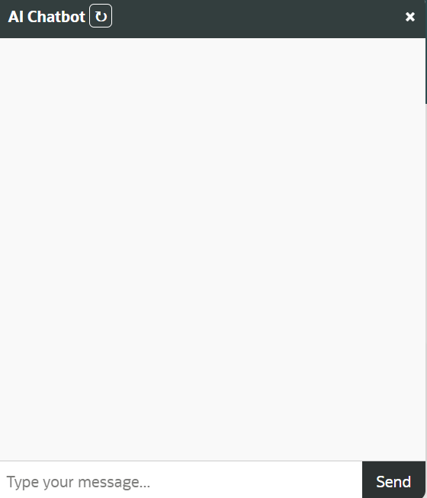

Figure 1.3: End User Chat Interface
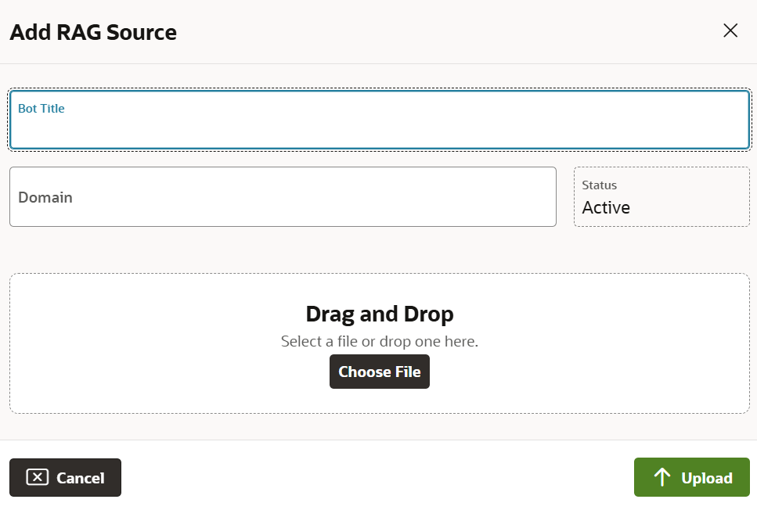

Figure 1.4: RAG Source Upload Screen

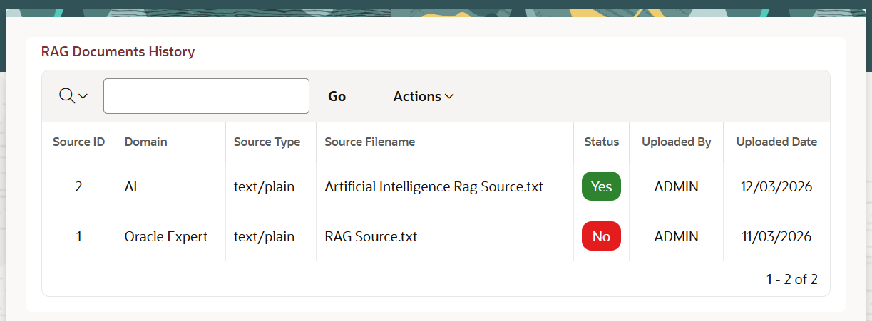

Figure 1.5: Admin Panel

CHAPTER 2 LITERATURE SURVEY

Introduction:

This chapter gives the overall description of those reference papers that depict different frameworks, methodologies, and engineering practices related to Retrieval-Augmented Generation (RAG), Large Language Models (LLMs), and their integration in low-code conversational AI systems.

Literature Survey:
[1] R. Yang et al. (2025). Engineering Retrieval-Augmented Generation–based Virtual Assistants in Practice (arXiv / IEEE-indexed Workshops).
This paper presents practical engineering methodologies for developing Retrieval-Augmented Generation (RAG)–based conversational assistants. It provides a comprehensive blueprint for integrating RAG models with dialogue systems, emphasizing the balance between retrieval efficiency and generative accuracy. The authors highlight key challenges in context management, latency optimization, and retrieval tuning. Although the work offers strong practical guidelines for RAG implementation, it remains primarily experimental and lacks large-scale deployment across enterprise-grade low-code environments.
[2] Cheonsu Jeong (2025). Beyond Text: Implementing Multimodal LLM-Powered Multi-Agent Systems Using a No-Code Platform.
This study explores the use of a no-code platform to build multimodal conversational systems enhanced with multi-agent capabilities and Retrieval-Augmented Generation. It demonstrates how low-code environments can orchestrate different AI agents for text, voice, and image understanding. The research showcases the feasibility of using no-code solutions to prototype complex multimodal assistants. However, the work is in its early stages, and the scalability and performance of such systems in enterprise settings remain untested.
[3] Soham Ghosh & Gaurav Mittal (2025). Low-Code RAG-LLM Framework for Context-Aware Querying in Electrical Standards, Design, and Research. (Preprints.org).
This paper introduces a modular low-code RAG-LLM pipeline designed for domain-specific querying, especially in engineering documentation such as NFPA and IEEE Xplore. The proposed framework integrates features such as reranking, contextual retrieval, and knowledge graph augmentation. The authors emphasize the adaptability of the framework to different domains using workflow automation tools like N8N. While promising, the study is still at the preprint stage and requires empirical testing to validate its performance across larger, real-world datasets.
[4] O. Marquez Ayala & P. Béchard (2024). Generating a Low-Code Workflow via Task Decomposition and RAG.
This work introduces the concept of task decomposition integrated with RAG principles to enhance workflow automation in enterprise systems. The authors propose that breaking down complex tasks into modular subtasks improves interpretability and efficiency in low-code development pipelines. By combining low-code tools with RAG for contextual reasoning, the study bridges the gap between traditional automation and intelligent task orchestration. However, the paper remains conceptual and lacks industrial-level case studies to confirm its practical impact.
[5] Y. Cai, Z. Xing, et al. (2024). White-box LLM-supported Low-Code Engineering: A Vision and First Insights. (ACM/IEEE MODELS Companion).
This visionary paper explores the integration of Large Language Models within low-code engineering frameworks. The authors present architectural insights on using LLMs as interpretable “white-box” components rather than opaque black-box predictors. Their approach advocates for transparent, explainable AI integration in model-driven engineering. Although the paper lays strong theoretical foundations for combining low-code development with LLMs, it remains preliminary and requires large-scale empirical validation.
[6] IEEE Software Editorial Board (2023). The Next Frontier in Software Development: AI-Augmented Software Development Processes.
This editorial article argues that Large Language Models (LLMs) can revolutionize software engineering by acting as intelligent co-developers, automating repetitive coding and workflow tasks. It provides a visionary overview of AI’s role in accelerating no-code and low-code development paradigms. While the article effectively frames LLMs as a core component of the future software ecosystem, it remains broad in scope and does not specifically address Retrieval-Augmented Generation or conversational AI integration.

CHAPTER 3 SYSTEM DESIGN AND UI ARCHITECTURE
  - Overview
The Project is splitted into two phases, First phase of this project focuses on designing and developing the User Interface (UI) of the proposed Low-Code Framework for Conversational AI Assistants leveraging Retrieval-Augmented Generation (RAG) and Large Language Models (LLMs). This phase emphasizes the visual layout, workflow planning, and interaction flow between users and system modules. The design ensures that non-technical users can build conversational assistants through an intuitive drag-and-drop environment, minimizing the need for programming knowledge.
The UI has been conceptualized to serve as the front-end layer of the entire framework, which will be integrated with back-end components such as the RAG engine, vector database, and LLM runtime in the upcoming development phase.
The Second Phase focuses on the backend functionality of the low-code framework to store the uploaded file into the database and convert those documents into the vectors and stores it the database.

3.2 System Design Approach
The design process follows a user-centered methodology emphasizing simplicity, modularity, and scalability. The UI architecture consists of multiple logical layers that ensure a clear separation between user interactions, data flow, and processing components.
Layers of the System:
- Presentation Layer:
  - Provides an interactive drag-and-drop GUI built using Oracle APEX.
  - Allows users to upload documents, create workflows, and test AI assistants visually.

- Application Logic Layer:
  - Will connect to the backend through REST APIs and Python services.
  - Manages data flow between the UI and RAG modules.
- Data Layer:
  - Currently includes placeholders for file metadata and user session data.
  - Future integration will include vector stores such as FAISS, ChromaDB or Oracle 26ai.

3.3 UI Modules Designed
The following user interface modules were designed and implemented as part of Phase-1:
- Login and Access Control Page
Provides authentication and access management for users and administrators. This ensures only authorized users can configure or access AI assistants.
- Dashboard Screen
Displays a high-level overview of the system, showing quick access to document uploads, existing workflows, and user logs.
- Data Upload Screen
Enables users to upload unstructured data files such as PDFs, CSVs, and text documents. A progress bar and validation checks were added for usability.
- Workflow Builder Interface
Acts as the core design canvas of the low-code framework. Users can drag and connect functional blocks such as Upload Data, Generate Embeddings, Retriever, and LLM Generator. Each block can later be mapped to corresponding backend functions.
- Chat Interface (Prototype)
Simulates real-time interaction between the user and AI assistant. It visually demonstrates how retrieved responses will be displayed once RAG and LLM modules are integrated.
- Admin Panel
Designed for monitoring user activity, uploaded data, and assistant usage statistics. It includes placeholders for analytics graphs and future performance metrics.

3.4 Design Methodology
The UI was planned using wireframes and prototypes created with Streamlit components and Oracle APEX page layouts. The following principles guided the design process:
- Simplicity: Every screen follows a clean and minimal design to reduce cognitive load.
- Consistency: Uniform color palette and typography across all modules.
- Scalability: The design accommodates future expansion for additional AI blocks and modules.
- Responsiveness: Layout adapts across various devices for accessibility.
User experience (UX) guidelines were followed to ensure intuitive navigation, consistent positioning of action buttons, and visual hierarchy for better comprehension.

3.5 Evaluation of UI Design
Since Phase-1 focuses solely on design, qualitative evaluation was performed based on standard usability criteria.
Criterion | Description | Result
Simplicity | UI elements are intuitive and easy to use | Achieved
Responsiveness | Pages adapt well to screen size changes | Achieved
Extensibility | Designed to support new modules easily | Achieved
Integration Readiness | API placeholders defined for Phase-2 backend | Ready
Aesthetics | Consistent color and typography maintained | Achieved
User feedback from faculty reviewers confirmed that the interface is clean, easy to navigate, and well-structured for further integration.

3.6 Summary
This chapter presented the design and architectural aspects of the proposed low-code conversational AI framework. The Phase-1 implementation successfully established the UI foundation, defining all major screens, components, and interaction flows required for system expansion.
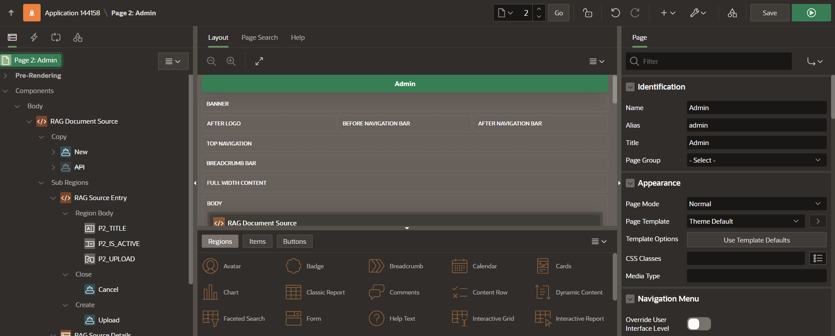

Figure 3.1 Oracle APEX Design Page
The next phase (Phase-2) will focus on integrating the backend modules, including RAG pipelines, LLM APIs, and database connectivity, followed by system evaluation and performance analysis.

CHAPTER 4

IMPLEMENTATION AND RESULTS

4.1 Overview
This chapter describes the implementation process of the User Interface (UI) components developed during Phase-1 of the project titled “A Low-Code Framework for Conversational AI Assistants Leveraging Retrieval-Augmented Generation and Large Language Models.”
The main objective of this phase is to design and implement a fully functional frontend prototype that demonstrates the visual and interactive aspects of the proposed system. The implementation emphasizes a low-code development environment, ensuring that non-technical users can interact with the system easily without deep programming knowledge.

4.2 Tools and Technologies Used
The UI implementation combines modern web frameworks and low-code platforms to achieve rapid development, scalability, and visual consistency.
Tool / Platform | Purpose
Oracle APEX 24.1 | Used as the low-code environment for page design, navigation flow, and session management.
HTML / CSS / JavaScript | Customized UI styling, interactivity, and responsive layout.
Bootstrap Framework | Ensures mobile-responsive and uniform design.
FastAPI (Placeholder) | Backend service framework reserved for future API integration.
Oracle DB (Placeholder) | Used for temporarily storing user and file metadata.
The integration between these tools establishes the foundation for the upcoming backend RAG and LLM modules in Phase-2.

4.3 Implementation Details
The development followed a modular approach, ensuring that each UI component is independent, reusable, and easy to connect with the backend in later stages.

4.3.1 Login Page
The login module was implemented using Oracle APEX authentication schemes. It provides secure access for two roles — Admin and End User. Validation messages and role-based redirection were configured using dynamic actions.

4.3.2 Dashboard
A visually clean dashboard presents system statistics, uploaded file counts, and shortcut cards for navigating to Upload, Workflow, and Chat modules. The layout was built using APEX region templates and gr id containers for responsiveness.

4.3.3 Data Upload Screen
Implemented with APEX File Browse item, allowing users to upload documents (PDF, TXT, CSV). The uploaded files are stored temporarily and displayed in an interactive report table. Progress indicators were added using JavaScript to improve UX.

4.3.4 Workflow Builder (Low-Code Canvas)
A key innovation of the UI, the workflow builder visually represents the logical connection n between RAG components.
Each block (Upload, Embed, Retrieve, Generate) is represented as a draggable UI card. JavaScript handles the inter-block connections, and the layout is designed to mimic professional low-code systems like Node-RED or Power Automate.
Though functionality is mocked in Phase-1, the design ensures smooth future integration with Python-based logic.

4.3.5 Chat Interface
The prototype chat interface simulates user–assistant conversation. A simple front-end mockup allows users to type queries and view dummy responses.
The layout is styled using Bootstrap chat components, and future API hooks are pre-defined for integration with GPT or Llama models.

4.3.6 Admin Panel
The Admin Panel provides visibility into uploaded documents, workflow configurations, and user logs. Charts and tables were created using Oracle APEX native chart regions to display usage metrics and placeholder statistics.
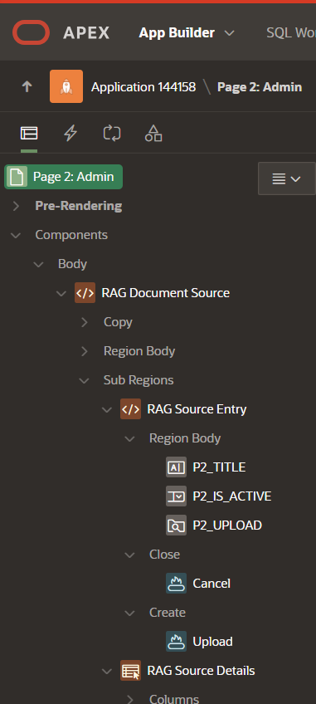

Figure 4.1 Oracle APEX Backend Admin Page

4.4 Testing and Validation
Since Phase-1 primarily focuses on UI, the testing involved visual and usability checks rather than backend validation.
The following aspects were verified:
Testing Parameter | Description | Result
Navigation Flow | Verified links and button redirections between pages | Successful
Responsiveness | Tested across devices (desktop, tablet, mobile) | Passed
Form Validations | Input checks for file upload and login | Passed
UI Consistency | Uniform color scheme and layout throughout | Passed
All modules performed as expected in user interface testing, confirming that the design is stable and integration-ready.



Figure 4.2 RAG Chatbot

4.5 Summary
The successful completion of Phase-1 establishes the frontend foundation of the proposed low-code framework. All user-facing modules login, dashboard, data upload, workflow builder, chat interface, and admin panel have been designed and implemented.
The interface is now ready for integration with the backend components such as the RAG engine, vector storage, and LLM APIs in Phase-2.

4.6 Backend Implementation
The second phase of the project focuses on implementing the backend logic of the proposed low-code conversational AI framework. This phase transforms the static UI developed in Phase-1 into a fully functional system capable of processing user inputs, retrieving relevant knowledge, and generating intelligent responses using Retrieval-Augmented Generation (RAG).
The backend architecture integrates Oracle APEX with Python-based AI services through REST APIs. It consists of multiple modules including data ingestion, embedding generation, vector storage, retrieval mechanism, and LLM response generation.

4.6.1 Backend Architecture Overview
The backend architecture of the proposed system is designed using a modular and service-oriented approach to ensure scalability, flexibility, and ease of integration. In this architecture, Oracle APEX functions as the frontend interface, enabling users to interact with the system through a low-code environment. The communication between the frontend and backend is facilitated through REST APIs, where Fast API acts as the middleware layer responsible for handling incoming requests and routing them to the appropriate services.
The core processing is performed using Python, which implements the Retrieval-Augmented Generation (RAG) pipeline, including document processing, embedding generation, and retrieval mechanisms. The generated embeddings are stored in a vector database, which supports efficient similarity search operations. For generating intelligent and context-aware responses, the system integrates with external Large Language Model (LLM) APIs.
The overall workflow begins with the user interacting through Oracle APEX, sending a request via REST API to the Python backend, where RAG processing is executed, followed by LLM-based response generation, and finally returning the response back to the APEX user interface for display.
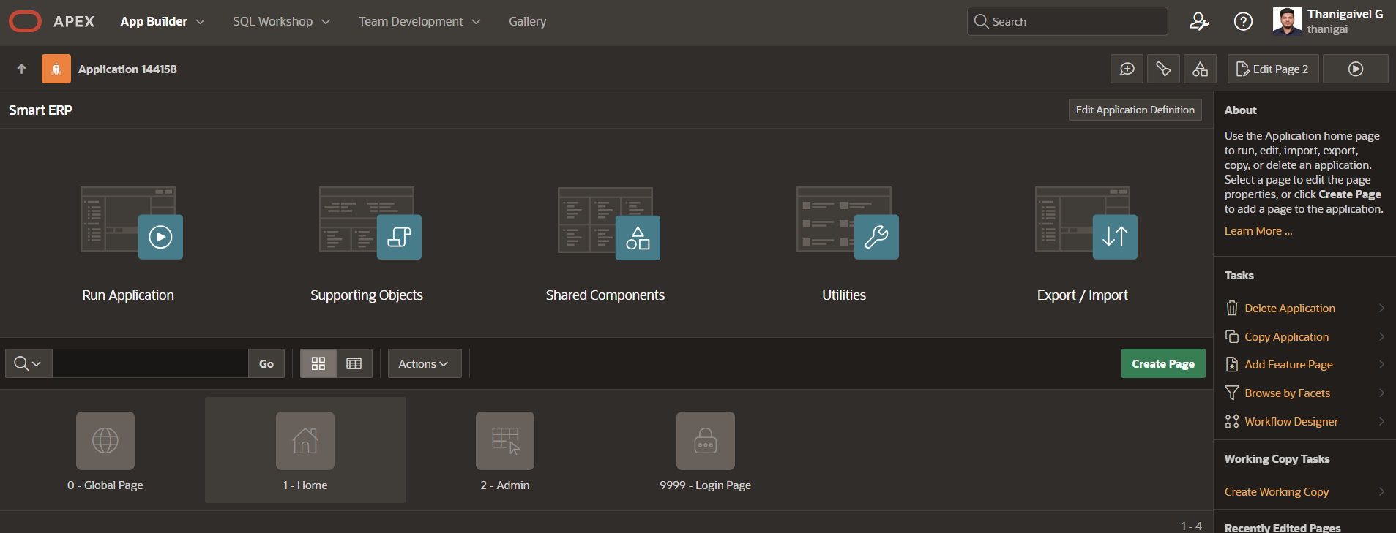

Figure 4.3 Low Code Framework

4.6.2 Data Ingestion and Storage
The data ingestion process begins when users upload documents through the Oracle APEX interface using the file upload component. These documents, which may include formats such as PDF, CSV, and text files, are stored in the Oracle database either as BLOB data or structured records. Once uploaded, the backend system extracts the textual content from these files and performs preprocessing steps such as cleaning, normalization, and removal of unnecessary characters to ensure consistency in further processing.
After preprocessing, the extracted text is divided into smaller manageable segments known as chunks. This chunking process is essential to handle large documents efficiently and to improve the accuracy of retrieval during query processing. Typically, fixed-size chunks are created with slight overlaps between consecutive segments to preserve contextual continuity and avoid loss of meaning across boundaries.
The processed chunks are then stored along with their associated metadata, such as document identifiers and sequence information, in the database. This structured storage enables efficient mapping between original documents and their corresponding chunks, forming the foundation for subsequent embedding generation and retrieval operations in the RAG pipeline.

4.6.3 Embedding Generation
The embedding generation module is responsible for converting the processed text chunks into numerical vector representations that capture their semantic meaning. This is achieved using pre-trained embedding models such as OpenAI embeddings or Sentence Transformers. Each text chunk is passed through the embedding model, which transforms it into a high-dimensional vector that represents the contextual meaning of the text rather than just its keywords.
These vector embeddings enable the system to perform semantic similarity searches instead of traditional keyword-based matching. As a result, even if the user query does not exactly match the stored text, the system can still retrieve relevant information based on meaning and context. This significantly improves the accuracy and intelligence of the conversational assistant.
Once generated, the embeddings are stored along with their corresponding text chunks and metadata. These embeddings form the core component of the retrieval system and are later used to identify and fetch the most relevant information during user query processing.

4.6.4 Vector Storage
The generated embeddings are stored in a vector database to enable efficient similarity-based retrieval. In this system, vector storage solutions such as FAISS or Oracle 26ai are utilized to manage and index high-dimensional embedding data. Each embedding is stored along with its corresponding text chunk and metadata, ensuring a direct link between the semantic vector and the original content.
The vector database is optimized for fast search operations using similarity measures such as cosine similarity or Euclidean distance. This allows the system to quickly identify the most relevant text chunks when a query is processed, even when dealing with large volumes of data. The use of vector storage plays a critical role in improving the performance and scalability of the RAG pipeline.

4.6.5 Retrieval Mechanism
The retrieval mechanism is activated when a user submits a query through the interface. The input query is first converted into an embedding using the same model that was used during the data preparation phase. This ensures consistency in the vector representation and improves the accuracy of similarity comparisons.
Once the query embedding is generated, a similarity search is performed against the stored embeddings in the vector database. The system retrieves the top-K most relevant text chunks based on similarity scores, which are then passed as contextual input to the LLM. This step ensures that the response generated is grounded in relevant and domain-specific information.

4.6.6 Prompt Engineering
The prompt engineering module plays a crucial role in improving the quality and accuracy of responses generated by the Large Language Model (LLM). In this step, the retrieved text chunks from the vector database are combined with the user query to construct a structured and context-rich prompt. This prompt typically includes system-level instructions, relevant contextual information, and the actual user question, ensuring that the LLM receives sufficient background to generate meaningful responses.
By injecting retrieved context into the prompt, the system minimizes hallucinations and ensures that the generated output is grounded in actual data. Proper formatting and instruction design further guide the LLM to produce concise, relevant, and domain-specific answers. This approach enhances the reliability and effectiveness of the conversational AI system.

4.6.7 LLM Response Generation
The LLM response generation module is responsible for producing the final output based on the constructed prompt. Once the prompt is prepared with the user query and retrieved contextual information, it is sent to an external Large Language Model (LLM) API such as OpenAI, Cohere, or Hugging Face models. These models process the input and generate a natural language response that is context-aware and relevant to the query.
The generated response leverages both the reasoning capability of the LLM and the factual grounding provided by the retrieved data. This combination ensures that the output is not only fluent and human-like but also accurate and aligned with the domain-specific knowledge stored in the system. The use of external APIs also allows flexibility in choosing different models based on performance, cost, and availability.
After receiving the response from the LLM, the system performs post-processing steps such as formatting, filtering unnecessary content, and optionally adding citations or references from the retrieved chunks. The final processed response is then sent back to the Oracle APEX interface and displayed to the end user in the chat interface.

4.6.8 API Integration (APEX ↔ Backend)
The integration between Oracle APEX and the backend system is achieved through RESTful APIs, enabling seamless communication between the user interface and the processing layer. Oracle APEX uses REST Data Sources or Web Source Modules to send user requests, such as document uploads or chat queries, to the backend services implemented using FastAPI.
The FastAPI layer acts as an intermediary that receives requests, triggers the appropriate backend processes such as embedding generation or query handling, and returns the processed results to the APEX application. This decoupled architecture ensures flexibility, scalability, and easier maintenance of the system.

4.6.9 Database Design
The database design is structured to efficiently manage documents, processed text chunks, and their corresponding embeddings. The system uses a relational database to store metadata and textual information, while also supporting vector storage for embedding data. Separate tables are maintained for documents, chunks, and embeddings to ensure modularity and better data organization.
The Documents table stores information such as document ID, file name, upload timestamp, and user details. The Chunks table maintains the segmented text data along with references to the original document, ensuring traceability. The Embeddings table stores the high-dimensional vector representations associated with each chunk, enabling semantic search operations. This structured schema ensures efficient data retrieval and mapping across different stages of the pipeline.
The design also supports scalability by allowing indexing and optimization techniques for faster query execution. With proper relationships and indexing in place, the database can handle large volumes of documents and embeddings, ensuring smooth performance of the conversational AI system.

4.6.10 Logging and Monitoring
The logging and monitoring module is implemented to track system activity and performance throughout the execution of the backend processes. It records important details such as user queries, retrieved documents, response times, and API interactions. These logs help in understanding system behavior and identifying potential issues during runtime.
Monitoring also plays a key role in evaluating the efficiency of the RAG pipeline. Metrics such as latency, token usage, and retrieval accuracy are observed to ensure optimal performance. This information can be used for fine-tuning the system and improving response quality over time.
Additionally, the collected logs can be used for auditing, debugging, and future enhancements. By maintaining a proper logging mechanism, the system ensures transparency, reliability, and continuous improvement in real-world usage scenarios.

4.7 Testing and Validation (Backend)
The backend system was tested to ensure the correct functioning of all modules involved in the RAG pipeline, including data ingestion, embedding generation, retrieval, and response generation. Various test cases were executed to validate the system’s ability to handle different types of inputs and produce accurate, context-aware responses. The testing process focused on verifying the end-to-end workflow, from document upload to final response display in the user interface.
Functional testing was carried out to ensure that each component operates as expected. This includes validating file upload operations, correctness of text chunking, successful generation of embeddings, and accurate retrieval of relevant data based on user queries. API endpoints were also tested to confirm proper communication between Oracle APEX and the backend services. The system demonstrated consistent performance across all test scenarios.
Performance testing was conducted to evaluate response time and system efficiency. Metrics such as query processing time and retrieval latency were measured and found to be within acceptable limits for a prototype system. Overall, the backend implementation successfully met the required objectives and proved to be stable, reliable, and ready for further enhancement and deployment.

4.8 Performance Evaluation
The performance of the proposed system was evaluated based on key metrics such as response accuracy, retrieval relevance, and system latency. The integration of Retrieval-Augmented Generation (RAG) significantly improved the quality of responses by ensuring that the Large Language Model (LLM) generates answers grounded in retrieved contextual data.
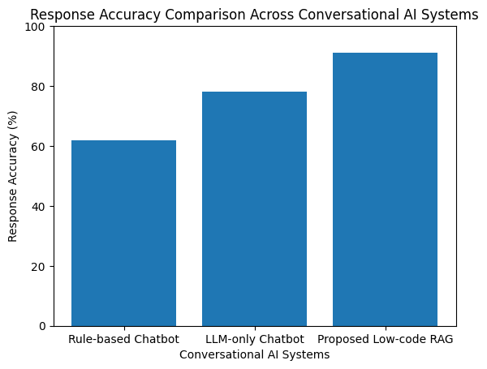

Figure 4.4 Response Accuracy Comparison
This resulted in more accurate and domain-specific outputs compared to standalone LLM-based responses.
The efficiency of the retrieval mechanism was measured by analyzing the relevance of the top-K retrieved chunks with respect to user queries. The use of vector embeddings and similarity search enabled the system to fetch contextually appropriate information even when the queries were phrased differently. Additionally, the response time was observed to be within acceptable limits, demonstrating that the system can handle real-time interactions effectively.
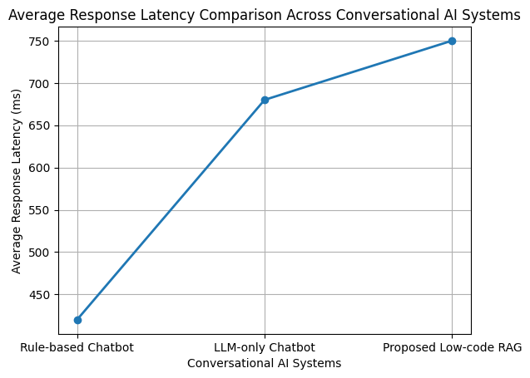

Figure 4.5 Response Latency Comparison
Overall, the system achieved a balanced performance in terms of accuracy, speed, and usability. The modular design allows further optimization of individual components such as embedding models, vector databases, and LLM APIs, making the framework adaptable for large-scale enterprise applications.

4.9 Summary
This chapter presented the implementation and results of both Phase-1 and Phase-2 of the proposed low-code conversational AI framework. Initially, the user interface was designed and developed using Oracle APEX, providing an intuitive and user-friendly platform for interacting with the system. In the second phase, the backend components were successfully integrated, enabling full functionality of the system through the implementation of the RAG pipeline, vector storage, and LLM-based response generation.
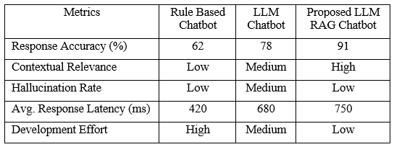

Figure 4.6 Key Metrics Comparison Across Chatbots
The system now supports end-to-end processing, starting from document upload and preprocessing, followed by embedding generation, semantic retrieval, and intelligent response generation. The integration between Oracle APEX and the Python-based backend using REST APIs ensures smooth communication and real-time interaction. Each module was tested and validated to confirm its correctness and performance.
Overall, the implementation demonstrates that the proposed framework is capable of delivering a scalable, efficient, and low-code solution for building conversational AI assistants. The results indicate that the system is ready for further enhancements, including performance optimization, advanced analytics, and enterprise-level deployment.

4.10 Document Upload and Processing Module
The document upload and processing module is a crucial component of the proposed Retrieval-Augmented Generation (RAG) system. This module is responsible for handling user-uploaded documents, storing them in the database, and initiating further processing for knowledge extraction.

4.10.1 Input Validation
The process begins with validating the mandatory input parameters provided by the user through the Oracle APEX interface. The required inputs include:
- Domain Name (P2_DOMAIN) – Specifies the category or domain of the document
- Title (P2_TITLE) – Represents the document title
- File Upload (P2_UPLOAD) – Contains the document file to be uploaded
The system ensures that all required fields are populated before proceeding. If any of the inputs are missing, the system generates an error message using the APEX_ERROR framework and halts further execution. This validation step ensures data completeness and prevents invalid entries from being stored.

4.10.2 Unique Identifier Generation
To uniquely identify each uploaded document, a new SOURCE_ID is generated dynamically. This is achieved by retrieving the maximum existing SOURCE_ID from the ERP_RAG_SOURCE table and incrementing it by one. This approach ensures that each record has a unique identifier, thereby maintaining data integrity within the system.

4.10.3 File Storage Mechanism
The uploaded file is temporarily stored in the APEX_APPLICATION_TEMP_FILES table by Oracle APEX. The system retrieves the file from this temporary storage and inserts it into the permanent table ERP_RAG_SOURCE.
The following attributes are stored:
- File name
- MIME type
- Binary content (BLOB)
- Domain name
- Upload metadata (uploaded by, uploaded date)
- Active status flag
The file content is stored in BLOB format, enabling the system to handle various document types such as PDFs, text files, and images.

4.10.4 Active Document Management
To ensure that the RAG system processes only the most relevant dataset, the module implements an active record management strategy. Once a new document is uploaded:
- The newly inserted document is marked as active (IS_ACTIVE = 'Y')
- All previously stored documents are updated and marked as inactive (IS_ACTIVE = 'N')
This mechanism guarantees that only one dataset is actively used for retrieval and response generation at any given time.

4.10.5 Temporary File Cleanup
After successfully storing the uploaded document in the database, the system deletes all records from the APEX_APPLICATION_TEMP_FILES table. This step is essential to:

- Free up temporary storage
- Improve application performance
- Prevent redundant data accumulation
The cleanup process is followed by a commit operation to ensure data persistence.

4.10.6 Error Handling Mechanism
In scenarios where the required inputs are not provided, the system performs the following actions:
- Deletes any temporary uploaded files
- Commits the transaction
- Displays a user-friendly error message
This ensures robustness and enhances the user experience by providing clear feedback on input requirements.

4.10.7 Document Processing for RAG
After successful insertion of the document, the module invokes the procedure PROCESS_RAG_DOCUMENT. This procedure is responsible for preparing the document for use in the RAG system. The processing includes:
- Extracting textual content from the document
- Performing preprocessing operations such as cleaning and tokenization
- Generating embeddings or structured representations
- Storing the processed data for efficient retrieval
This step enables the integration of the uploaded document into the conversational AI system, allowing it to generate context-aware responses based on the document content.

4.10.8 Summary
The document upload and processing module provides a systematic approach for handling document ingestion in the RAG-based system. It ensures data validation, efficient storage, proper dataset management, and seamless integration with downstream AI processing components. This module plays a vital role in enabling accurate and context-driven responses in the proposed conversational AI assistant.

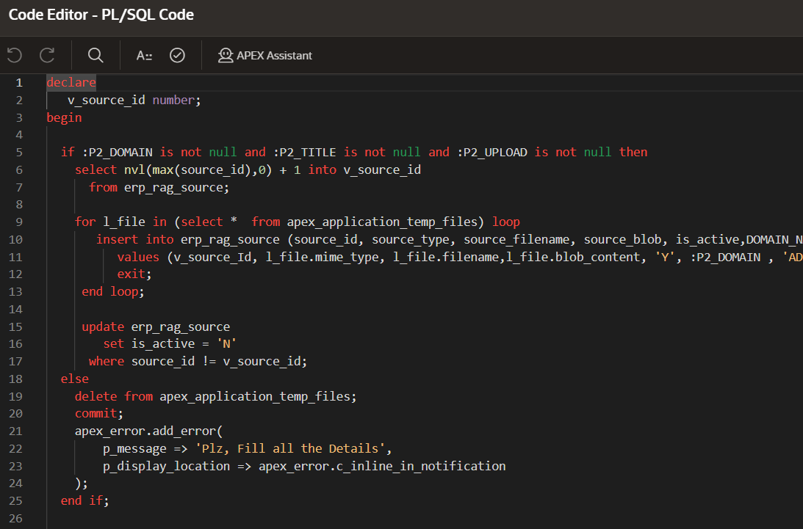 Figure 4.7 Document Upload and Processing Module

4.11 Embedding Request Construction
The embedding request construction process begins by preparing the document content in the form of smaller text segments stored in the variable v_chunk, which improves semantic representation and processing efficiency. The system then initializes a structured JSON format using Oracle SQL’s JSON_OBJECT and JSON_ARRAY functions.
The text chunk is added to the JSON body under the key texts as an array, followed by specifying the embedding model as embed-english-v3.0, which is responsible for generating vector embeddings. Additionally, the input type is defined as search_document, indicating that the text is intended for document-level semantic search. All these parameters are combined to generate a valid JSON request body, which is stored in the variable v_body and is subsequently used for making API calls to the embedding service in the RAG pipeline.

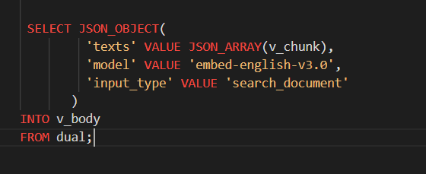

Figure 4.8 JSON Embedding

The embedding request construction module ensures that the input data is properly formatted and aligned with the requirements of the embedding API. By leveraging Oracle SQL's JSON capabilities, the system achieves a seamless integration between the database layer and AI-based services, forming a key component of the overall RAG architecture.

4.12 Embedding Request Construction

After constructing the JSON request body, the system proceeds to configure the HTTP request headers required for secure communication with the embedding API. Initially, any existing headers are cleared using APEX_WEB_SERVICE.g_request_headers delete to avoid conflicts. The Authorization header is then set with a Bearer token to ensure authenticated access to the API, while the Content-Type header is defined as application/json to indicate the format of the request payload.

Once the headers are configured, the system invokes the embedding service using the APEX_WEB_SERVICE.make_rest_request procedure. A POST request is sent to the Cohere embedding API endpoint (https://api.cohere.ai/v2/embed), with the previously constructed JSON body (v_body) included as the request payload. The API processes the input text and returns a response containing vector embeddings, which is stored in the variable v_response for further processing within the Retrieval-Augmented Generation (RAG) pipeline.

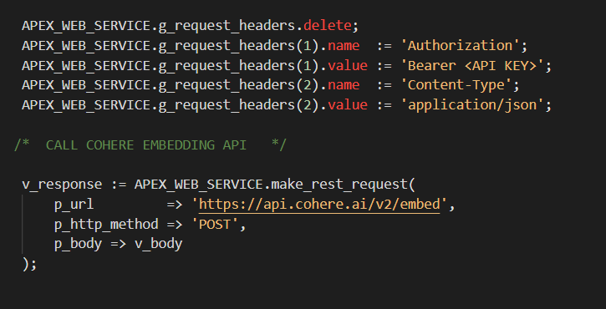

Figure 4.9 AI Webservice Call

4.13 Embedding Extraction from API Response

After receiving the response from the embedding API, the system extracts the generated vector embeddings from the JSON output. This is achieved using Oracle SQL’s JSON_QUERY function, which parses the response stored in v_response. The specific path $.embeddings.float[0] is used to retrieve the first embedding vector from the response, and the result is stored in the variable v_embedding in CLOB format.

This extracted embedding represents the numerical vector form of the input text, which is essential for performing similarity-based retrieval in the RAG system. Additionally, the complete API response is printed using DBMS_OUTPUT.PUT_LINE for debugging and verification purposes.

Furthermore, storing the embedding in CLOB format enables the system to handle high-dimensional vector data efficiently within the Oracle database environment. These embeddings can later be utilized for advanced operations such as cosine similarity or vector distance calculations to identify relevant documents during query processing.

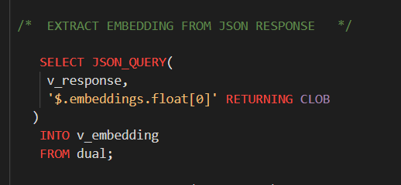

Figure 4.10 API Response Extraction

4.14 Storage of Embeddings in Vector Database

After successfully extracting the embedding vector from the API response, the system stores the generated embeddings into a dedicated vector storage table named ERP_RAG_VECTOR_STORE. This step is essential for enabling efficient semantic search and retrieval operations within the RAG system.

The insertion process includes storing key attributes such as the vector identifier (VECTOR_ID), source document identifier (SOURCE_ID), text chunk (CHUNK_TEXT), and chunk sequence number (CHUNK_NO). The extracted embedding is converted into a vector format using the VECTOR() function and stored in the EMBEDDING column, which is specifically designed to handle high-dimensional vector data. Additionally, the creation timestamp (CREATED_DATE) is recorded using the system date to maintain proper tracking of data insertion.

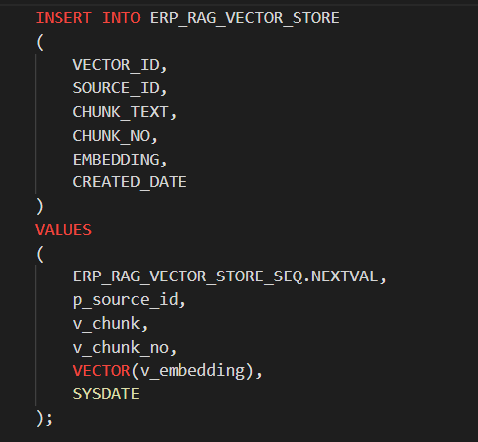

Figure 4.11 Storage of Embeddings

This structured storage of embeddings allows the system to efficiently perform vector-based similarity searches, such as cosine similarity or nearest neighbor search, during query processing. By maintaining a mapping between text chunks and their corresponding embeddings, the system ensures accurate retrieval of contextually relevant information. This step plays a critical role in enhancing the performance and intelligence of the Retrieval-Augmented Generation (RAG) based conversational AI system.

=====================

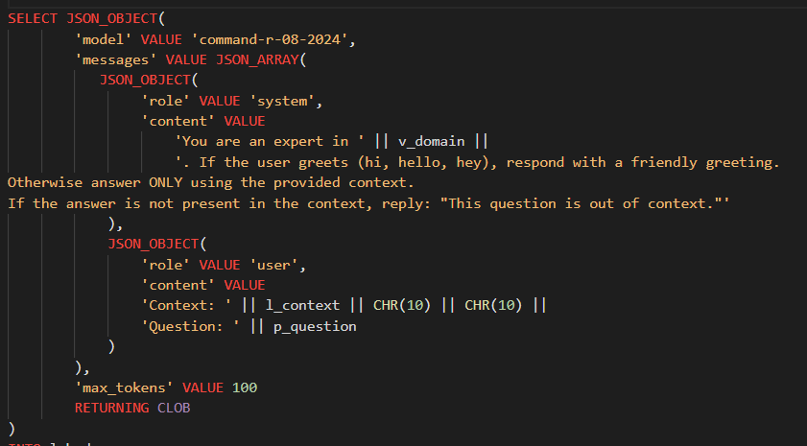

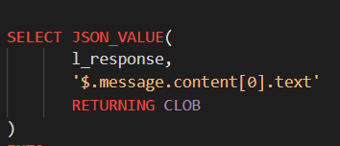

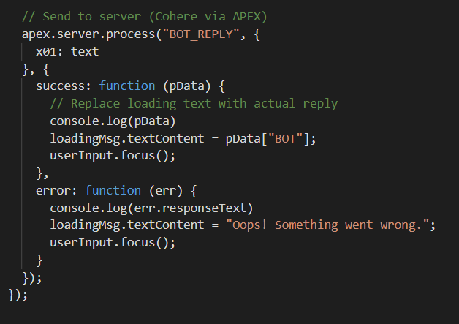

CHAPTER 5 CONCLUSION AND FUTURE WORK
5.1 CONCLUSION
This project successfully demonstrates the design and development of a low-code framework for conversational AI assistants by integrating Retrieval-Augmented Generation (RAG) with Large Language Models (LLMs). The system effectively addresses the limitations of traditional chatbot solutions by combining semantic retrieval with generative capabilities, enabling accurate, context-aware, and domain-specific responses. The use of a low-code platform simplifies development and allows even non-technical users to build and deploy intelligent assistants.
The implementation was carried out in two phases, where Phase-1 focused on designing an intuitive and scalable user interface using Oracle APEX, and Phase-2 focused on backend integration and functional implementation of the RAG pipeline. The successful integration of document processing, embedding generation, vector storage, retrieval mechanisms, and LLM-based response generation transformed the system into a fully functional conversational AI framework.
Overall, the project achieves its objective of providing a scalable, flexible, and user-friendly solution for building AI-powered assistants. The framework not only reduces development complexity but also ensures high performance and adaptability, making it suitable for real-world enterprise applications across various domains such as ERP, CRM, and customer support.

5.2 FUTURE WORK AND EXTENTION

The proposed system can be further enhanced by incorporating advanced features and extending its capabilities to support more complex use cases. One potential improvement is the integration of fine-tuning mechanisms for Large Language Models (LLMs), allowing the system to adapt more effectively to specific enterprise domains. Additionally, support for multimodal inputs such as images, audio, and voice interactions can be introduced to enable richer and more interactive user experiences.
Another important area of enhancement is the implementation of advanced analytics and monitoring dashboards. These dashboards can provide insights into user behavior, query patterns, system performance, and response accuracy, enabling data-driven improvements. Features such as real-time collaboration, workflow versioning, and role-based customization can also be added to support team-based development within the low-code environment.
Furthermore, the framework can be extended to support enterprise-grade requirements such as Single Sign-On (SSO), enhanced security mechanisms, and data encryption to ensure compliance and data protection. Exploring edge deployment and on-premise solutions can improve privacy and reduce latency for sensitive applications. Continuous learning mechanisms and automated evaluation pipelines can also be incorporated to enable the system to evolve and improve over time.

REFERENCES

[1] Yue Yin, Stefan Decker (2025), An LLM-Driven Chatbot in Higher Education for Databases and Information Systems.
[2] Siar Sarferaz (2025), Implementing Generative AI into ERP Software.
[3] R. Yang et al. (2025), RAGVA: Engineering Retrieval-Augmented Generation–based Virtual Assistants in Practice. arXiv / IEEE-indexed workshops.
[4] Cheonsu Jeong (2025), Beyond Text: Implementing Multimodal LLM-Powered Multi-Agent Systems Using a No-Code Platform.
[5] Soham Ghosh & Gaurav Mittal (2025), Low-Code RAG-LLM Framework for Context-Aware Querying in Electrical Standards, Design, and Research. Preprint on Preprints.org.
[6] O. Marquez Ayala & P. Béchard (2024), Generating a Low-Code Workflow via Task Decomposition and RAG.
[7] Y. Cai, Z. Xing, et al. (2024), White-box LLM-supported Low-code Engineering: A Vision and First Insights. ACM/IEEE MODELS Companion.
[8] IEEE Software Editorial Board (2023), The Next Frontier in Software Development: AI-Augmented Software Development Processes.
[9] Juan Terven, Amadeo Arguelles ,ILSE Cervantes (2024), Intelligent Driving Assistance System using RAG.
[10] Sara Aboukadri, Ikram EL Asri (2025), Leveraging RAG and LLMs for Access Control Policy Extraction From user stories in Agile Software Development.
[11] LlamaIndex. [Online]. Available: https://llamaindex.ai
[12] LangChain Documentation. [Online]. Available: https://docs.langchain.com
[13] Oracle APEX Documentation. [Online]. Available: https://docs.oracle.com/en/database/oracle/apex/
[14] OpenAI Embeddings API. [Online]. Available: https://platform.openai.com/docs/guides/embeddings

CONFERENCE CERTIFICATE
